Step 1: Create external table -- hive_partition

**hive> create external table hive_partition (EmployeeID Int,FirstName String,Designation String,Salary Int,Department String) row format delimited fields terminated by ","**

**> location '/home/training/Desktop/Hive/hive partitioning';**

Step 2: Load data into -- hive_partition

hive> load data local inpath '/home/training/Desktop/Hive/partition' into table hive_partition;

Step 3 :

Create partition table – partition_table

hive> create table partition_table (EmployeeID Int,FirstName String,Designation String,Salary Int) PARTITIONED BY (Department String) row format delimited fields terminated by ",";

Step 4 :

Load the partitioned table

hive> Insert into table partition_table partition (department='A') SELECT EmployeeID, FirstName,Designation,Salary FROM hive_partition where department = 'A';

hive> Insert into table partition_table partition (department='B') SELECT EmployeeID, FirstName,Designation,Salary FROM hive_partition where department = 'B';

hive> Insert into table partition_table partition (department='C') SELECT EmployeeID, FirstName,Designation,Salary FROM hive_partition where department = 'C';

***2. Dynamic Partition – Single insert to partition table***

Change the 4 proiperties.

hive> insert overwrite table partition_table PARTITION(department) SELECT EmployeeID, FirstName,Designation,Salary,department FROM hive_partition;

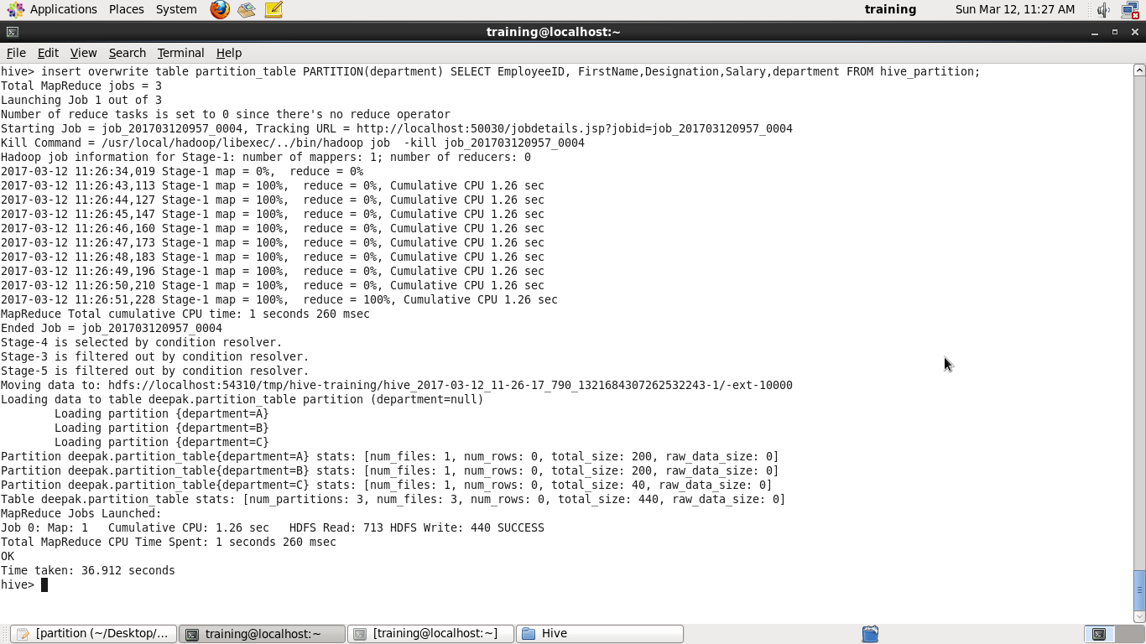

Try partitioning by salary;

hive> create table partition_table_salary2 (EmployeeID Int,FirstName String,Designation String,Department String) PARTITIONED BY (Salary int) row format delimited fields terminated by ",";

INSERT OVERWRITE TABLE partition_table_salary2 PARTITION(Salary) SELECT EmployeeID, FirstName, Designation, Salary, department FROM hive_partition;

